Email and messaging

Email clients and servers

Email is one of the most popular client/server applications on the internet.

**Email servers run server software that enable them to interact with clients and with other email servers over the network.**

**Each mail server receives and stores mail for users who have mailboxes configured on the mail server.**

**Each user with a mailbox must then use an email client to access the mail server and read these msges.**

Many internet msges systems use a web-based client to access email.

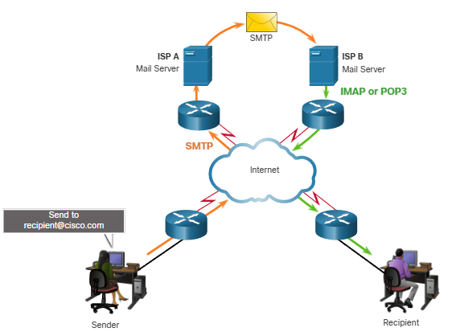

Email protocols

Simple mail transfer protocol (SMTP)

**SMTP is used by email client to send msges to its local email server.**

The local server then decides if the msg is destined for a local mailbox or if the msg is addressed to a mailbox on another server.

**If the server has to send the msg to a different server, SMTP is used between those 2 servers as well.** SMTP requests are sent to port 25.

Post office protocol (POP3)

**A server that supports POP clients receives and stores msges addressed to its users.**

**When the client connects to the email server, the msg are downloaded to the client. By default, msges are not kept on the server after they have been accessed by the client**. Clients contact POP3 servers on port 110

Internet message access protocol (IMAP4)

**A server that supports IMAP clients also receives and stores msges addressed to its users.**

However, unlike POP, IMAP **keeps the msg in the mailboxes on the server, unless they are deleted by the user.**

The most current version of IMAP is IMAP4 which listens for client requests on port 143

Text messaging

**Text msging, is one of the most popular communication tools in use today.**

**In addition, text msging software is built into many online applications**, spartphone aps and social media sites.

Both clients can simultaneously send and receive msges.

text msging enables users to communicate or chat over the internet in real-time.

Text msging services **on a computer are usually accessed through a web-based client** that is integrated into a social media or information sharing site.

These clients usually only connect to other users of the same site.

**There are also a number of standalone text msge clients. These applications are available for a wide variety of operating systems and devices.**

**A mobile version is typically offered.**

In addition to text msges, these clients support the transfer of documents, video, music, and audio files

Internet phone calls

Making telephone calls over the internet is becoming increasingly popular. **An internet telephony client uses peer-to-peer technology similar to that used by instant messaging.**

IP telephony makes use of voice over IP (VoIP) technology, which converts analog voice signals into digital data.

The voice data is encapsulated into IP packets which carry the phone call through the network.

When IP phone software has been installed, the user selects a unique name.   
 This is so that calls can be received from other users. Speakers and a microphone, are required.

**Calls are made to other users of the same service on the internet, by selecting the username from a list.**

A call to a regular telephone requires using a gateway to access the public switches telephone network (PSTN).

Depending on he service, there may be charges associated with this type of call. The protocols and destination ports used by internet telephone applications can vary based on the software.